

Clinical Fellowship Application

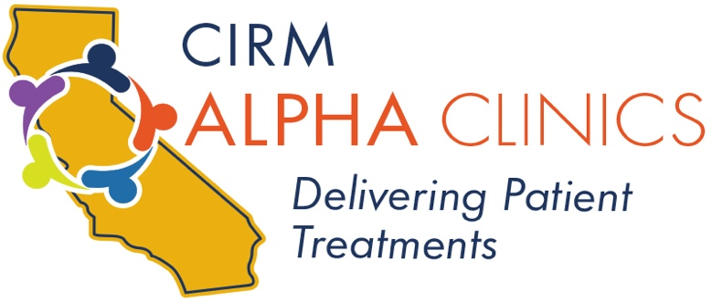

**Call for Applications**

**UCSF Alpha Stem Cell Clinic Fellow**

Fellowship applications are now available for **physician scientists** who are committed to academic research careers discovering and translating novel applications of cell-based therapeutics to clinical problems.

**Priority will be given to MDs* who are currently in or have recently completed clinical fellowship training and have commenced a clinical or translational laboratory project focused on stem cell biology at UCSF Health. Early stage Jr. Faculty are also encouraged to apply.**

**\* PhDs are not eligible for this Fellowship**

The fellowships are supported by the UCSF Alpha Stem Cell Clinic funded by the California Institute for Regenerative Medicine (CIRM). Fellows will be initially appointed for one year, with an additional year of support possible, dependent upon demonstrated productivity.

Period of Funding: July 1, 2021 – June 30, 2022

Amount of funding: $75,000 toward salary plus commensurate benefits

$5,000 for tuition & fees

$2,000 travel to related scientific conference

Completed applications along with mentor letters of support, should be submitted electronically to the UCSF Alpha Stem Cell Clinic at [alphascc@ucsf.edu](mailto:alphascc@ucsf.edu?subject=ASCC%20Fellowship%20Application) and must be received by **February 1, 2021**.

Funding announcements made by April 1, 2021

Funding will commence July 1, 2021

Please forward any questions to: [alphascc@ucsf.edu](mailto:alphascc@ucsf.edu?subject=ASCC%20Fellowship)

|  |  |  |  |  |
| --- | --- | --- | --- | --- |
| **PROJECT TITLE:** | | | | |
| NAME OF APPLICANT/FELLOW | | CURRENT POSITION TITLE:  START DATE IN MENTOR’S LABORATORY: | | |
| NAME OF MENTOR | |
| EDUCATION/TRAINING *(Begin with baccalaureate, and include postdoctoral training)* | | | | |
| INSTITUTION AND LOCATION | DEGREE  *(if applicable)* | | DATES  (month, year) | FIELD OF STUDY |
|  |  | |  |  |
|  |  | |  |  |
|  |  | |  |  |
|  |  | |  |  |
|  |  | |  |  |

**1. Personal Statement: Please outline your scientific and professional goals. (limit, one paragraph)**

**2. Relevance to Cell-Based Therapeutics: Please describe the clinical significance of your proposed project, and its relevance to cell-based therapeutics. (limit, 1 paragraph)**

**3. Research Plan: Please describe the research you would undertake as a CIRM Scholar.**

**(Mandatory limits: 2 pages total; min. margin width 1 inch, min. font size Arial 11 point)**

**Research Plan, continued:**

**4. Figures, Tables and Literature Cited: (please attach any figures or tables and their legends, and list all bibliographic references cited in the research plan. Mandatory limit, 1 page)**